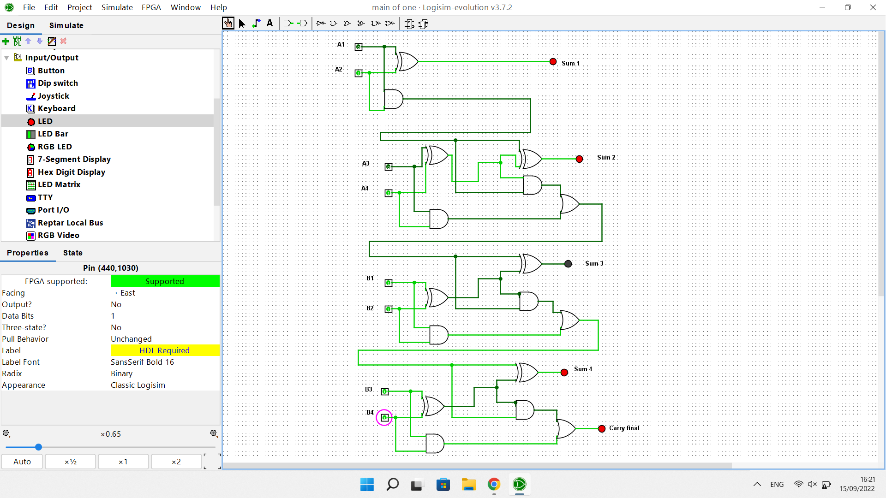

| Input A | Input B | Output |
| --- | --- | --- |
| 0101 | 0000 | Sum 1,2 |
| 0101 | 0001 | Sum 1,2,4 |
| 0101 | 0010 | Sum 1,2,4 |
| 0101 | 0011 | Sum 1,2,carry |
| 0101 | 0100 | Sum 1,2,3 |
| 0101 | 0101 | Sum 1,2,3,4 |
| 0101 | 0110 | Sum 1,2,3,4 |
| 0101 | 0111 | Sum 1,2,3,carry |
| 0101 | 1000 | Sum 1,2,3 |
| 0101 | 1001 | Sum 1,2,3,4 |
| 0101 | 1010 | Sum 1,2,3,4 |
| 0101 | 1011 | Sum 1,2,3,carry |
| 0101 | 1100 | Sum 1,2,4 |
| 0101 | 1101 | Sum 1,2,carry |
| 0101 | 1110 | Sum 1,2,carry |
| 0101 | 1111 | Sum 1,2,4,carry |

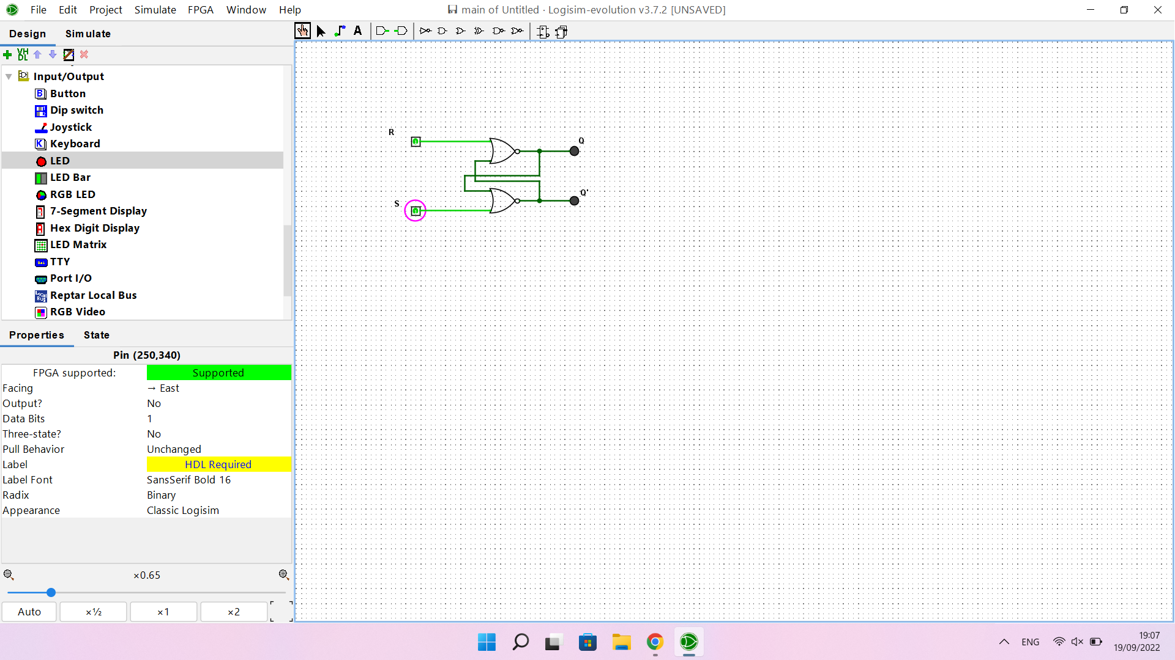

| Set | Reset | Q | Q’ |
| --- | --- | --- | --- |
| 1 | 0 | 1 | 0 |
| 1 | 1 | 0 | 0 |
| 0 | 1 | 0 | 1 |
| 1 | 1 | 0 | 0 |

The other led lights up.

It can be used to store data

No signal for both LEDs can cause electrical problems.

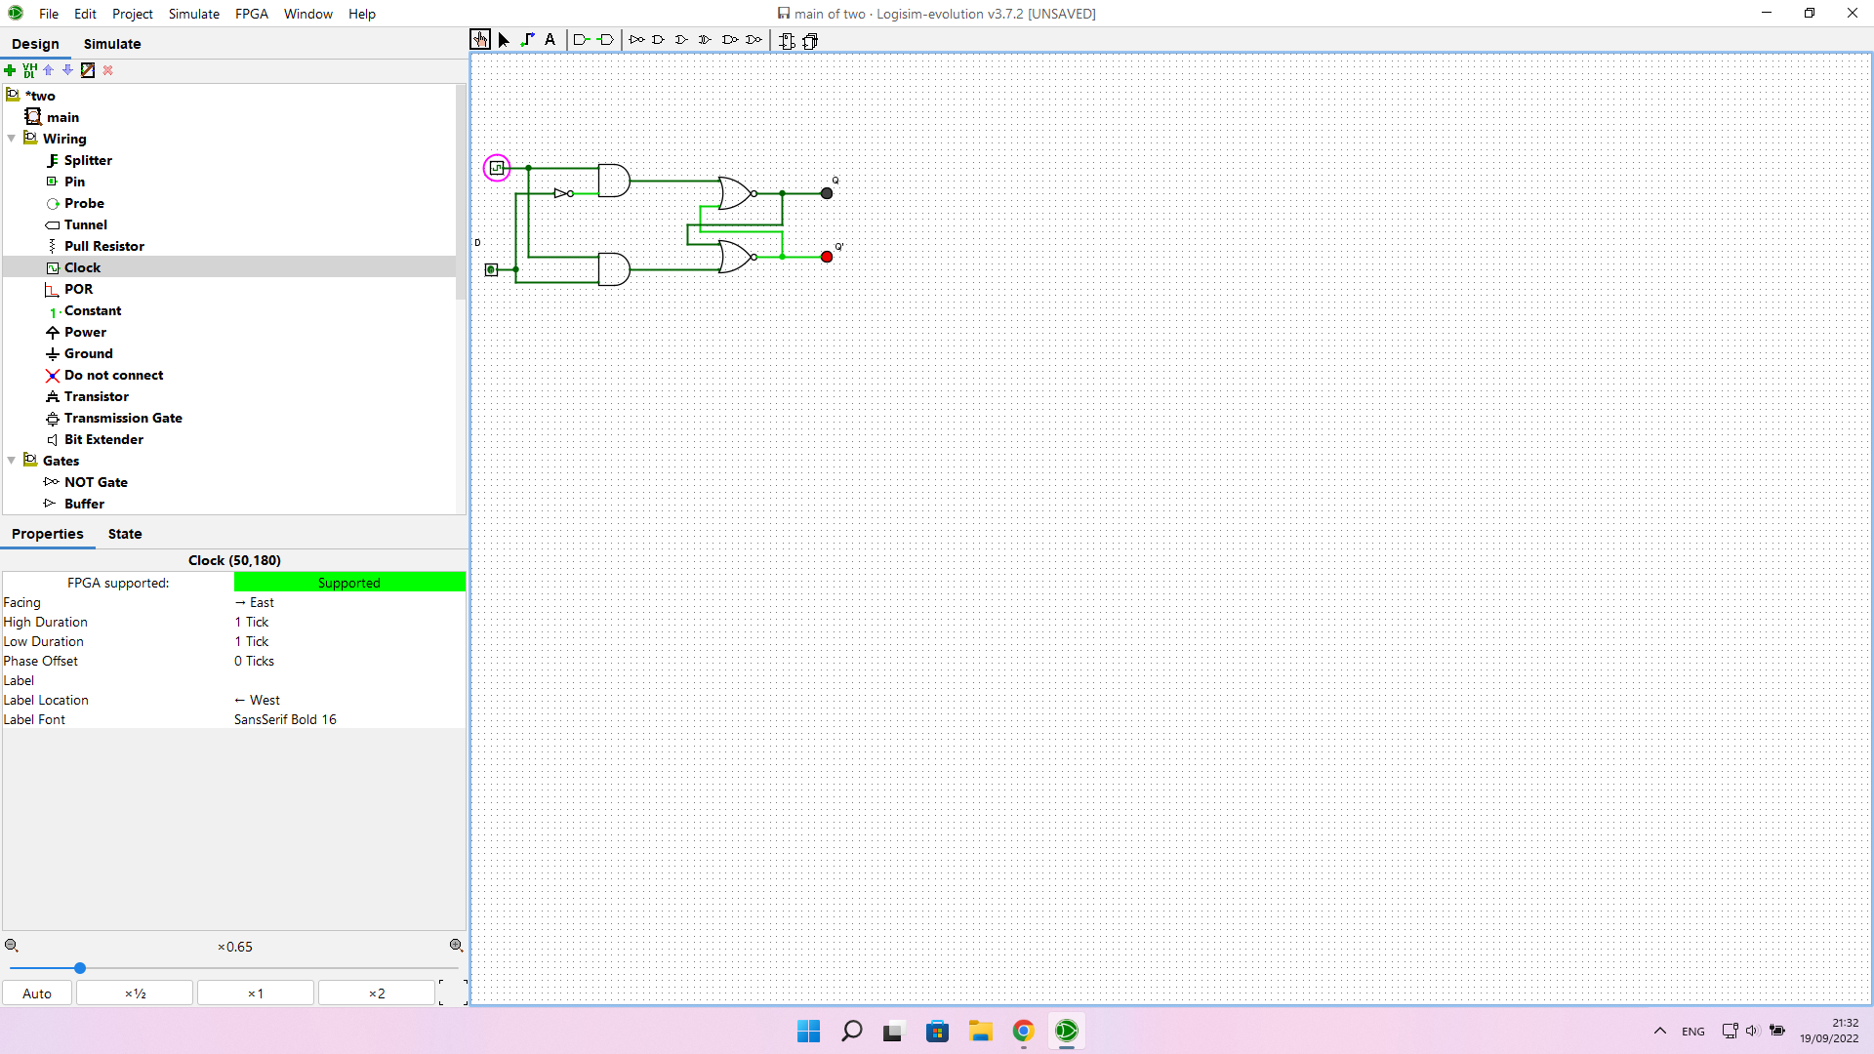

| Clock | Pin | Q | Q’ |
| --- | --- | --- | --- |
| 0 | 0 | 1 | 0 |
| 0 | 1 | 1 | 0 |
| 1 | 1 | 1 | 0 |
| 1 | 0 | 0 | 1 |

it makes both input aren’t 1 at the same time

if the clock is turned off then nothing will change when clicking pin

it can be used in more complicated ic which can’t work with 2 1 at the same time

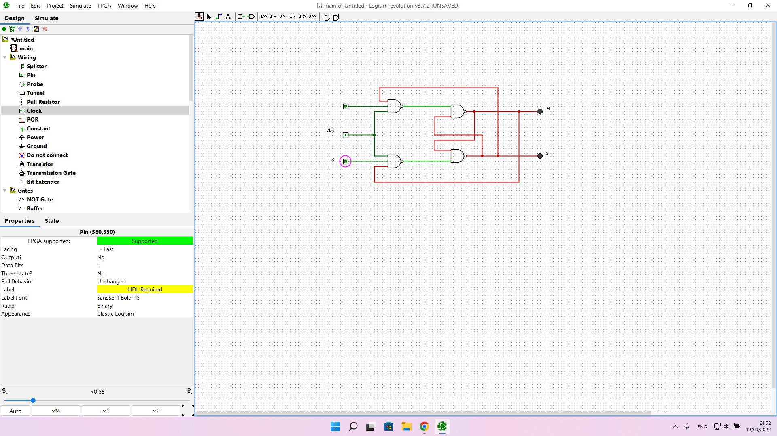

| J | K | Q(when clocked) | Q’(when clocked) |
| --- | --- | --- | --- |
| 0 | 0 | no changes | no changes |
| 1 | 0 | 0 | 1 |
| 0 | 1 | 1 | 0 |
| 1 | 1 | toggle | toggle |

connect j and k inputs to d with the not gate

make J = K = 1